**Class Diagram:**

* Class diagram is a structural diagram.

* Class Diagram Diagram provides a basic notation for other structure diagrams prescribed by UML

* A class notation consists (Class Name, Class Attributes, Class member Functions)

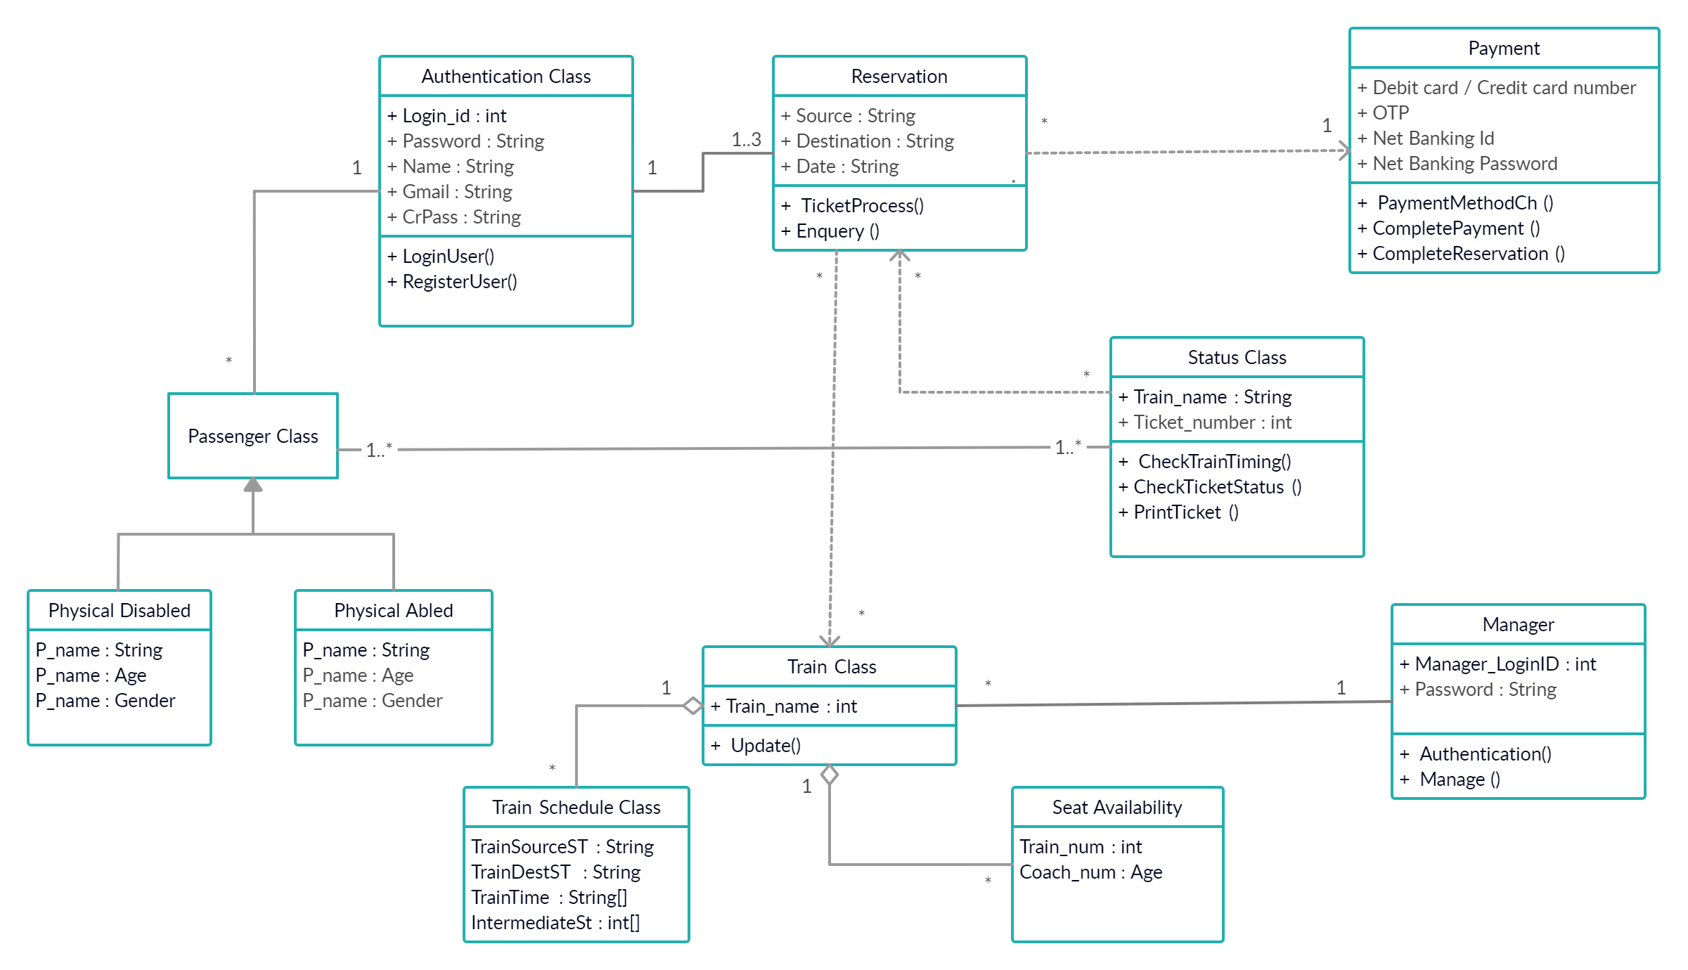

**Our class diagram represents**

1. Generalization between Passenger and Physical Disabled - physical Abled class.

Passenger class is a super class (parent class) of 2 child classes.

1. Simple Association between :
2. Passenger and Authentication Class
3. Authentication and Reservation Class
4. Passenger and Status Class
5. Aggregation between Train class and Train Schedule – Seat Availability Class
6. We have 3 dependencies :
7. Reservation class depends on Train class and Payment Class
8. Status class depends on Reservation Class
9. Multiplicity used in every relation:
10. ‘*’ means many
11. ‘1’ means one
12. ‘1..3’ means less than equal to three and greater than quual to one